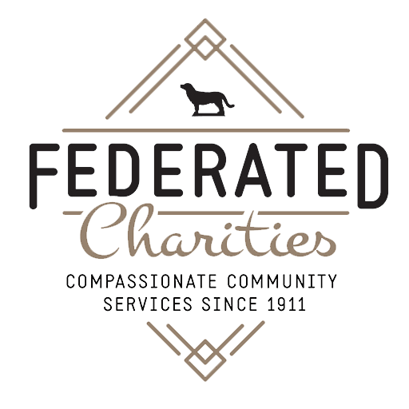**For Immediate Release October 15, 2024**

**Federated Charities Launches Love Locks of Frederick Fundraiser**

**to Support Courtyard Renovation**

*The nonprofit center’s fundraiser will transform into their newest public art installation, putting the Frederick community’s dedication on display*

**FREDERICK, Md.** — Federated Charities, Frederick’s only nonprofit center, is calling on the community to help close a $12,000 funding gap for the renovation of their historic courtyard and garden on Market Street. In addition to contributing to the project, patrons will have the unique opportunity to participate in Frederick’s newest public art project, Love Locks of Frederick, inspired by the famous love lock bridge in Paris.

For every $125 donated, a padlock and tag with the name of the donor, or the name the donor designates, will be placed on a section of the Federated Charities fence. The Love Locks fence will then become a permanent public art installation after the courtyard renovations are complete, symbolizing the city’s support and unity for the nonprofits that make up the community safety net.

Federated Charities’ courtyard renovation will preserve the historical integrity of their space while creating a welcoming community meeting area for the organization’s nonprofits and their clients. Ruppert Landscape generously donated their time and resources towards the planning and eventual execution of the renovations, which will include rehabbing the existing Leda and the Swan fountain, hardscaping to create meeting space, planting native plants and flowers, and creating a more accessible entryway.

“We know Frederick has a lot of love to give, we see it every day in the generosity of our community, so our new Love Locks fence will be a visual symbol of our community’s dedication to each other,” said Elin Ross, Executive Director of Federated Charities. “By supporting this project, you are supporting a number of organizations that provide essential services to thousands of individuals and families in Frederick County - what a wonderful way to honor someone or give a unique gift as we head into the holiday season.”

This project is one of four vital building initiatives planned that will improve accessibility, enhance security, and promote green spaces at the organization. Federated Charities has already raised over $100,000 for these projects, and this final fundraiser will bring them across the finish line.

To make your donation and become part of Love Locks of Frederick, visit [www.federatedcharities.org/love-locks-frederick/](https://www.federatedcharities.org/love-locks-frederick/). Your support will help Federated Charities continue their mission of strengthening our community and ensure that the nonprofits who call their building home can continue to provide vital services to those in need.

**About Federated Charities:**

Federated Charities is the only nonprofit center in Frederick and offers affordable, operational space to emerging and established nonprofit organizations. For more than 100 years, Federated Charities’ mission has been to weave together the kinds of programs that make up the community safety net. This commitment has generated millions of dollars that organizations can use for critical services in our community. To learn more, visit [federatedcharities.org](http://federatedcharities.org).

**Contact:**

Eve Butt

Senior Marketing Strategist

Postern

[Eve@Posternagency.com](mailto:Eve@Posternagency.com)

610-761-2558